- Environmental Pollution can be defined as any undesirable change in physical, chemical or biological characteristics of any component of the environment, i.e., air, water, soil which can cause harmful effects on various forms of life or property.
Pollution: The term pollution can be defined as influence of any substance causing nuisance, harmful effects and uneasiness to the organisms.
Pollutant: Any substance causing nuisance or harmful effects or uneasiness to the organisms, then that particular substance may be called as the pollutant.

- Air Pollution and human health;
Since air is essential for survival, it must be kept clean and free of pollutants, like oxides of carbon, sulfur and nitrogen that are discharged into the atmosphere through industrial waste units and by burning of fuels in automobiles (fossil fuel) or even bio-fuels.
Air pollution severely affects human health; it is responsible for acute and chronic respiratory problems such as lung infections, asthma, and even cancer. It is also responsible for acid rain in megacities.

- Primary pollutants: Primary air pollutants are emitted directly into the air from sources. They can have effects both directly and as precursors of secondary air pollutants (chemicals formed through reactions in the atmosphere), which are discussed in the following section.
Examples, SO2, NO, NO2, CO and other volatile compounds
Primary pollutants, i.e. CO, CO2 are emitted directly into the atmosphere from fossil fuel and bio-fuel burning; others are Nox, SO2, hydrocarbons, and SPM.

- FOG: Mist and fog are caused by water droplets in the air, and the only difference is how far you can see.
Fog is a complex atmospheric phenomenon. It is a visible mass consisting of cloud water droplets or ice crystals suspended in the air at or near the Earth's surface. Fog can be considered a type of low-lying cloud and is heavily influenced by nearby bodies of water, topography, and wind conditions. In turn, fog has affected many human activities, such as shipping, travel, and warfare.

- SMOG: Smog is what happens when pollution causes low-lying ozone. Smog is a kind of air pollution, originally named for the mixture of smoke and fog in the air. Classic smog results from large amounts of coal burning in an area and is caused by a mixture of smoke and sulphur dioxide. In the 1950s a new type of smog was witnessed, known as Photochemical Smog.

- AEROSOLS; Aerosols are Micron-size particles of solid or liquid phase, dispersed in the atmosphere. Aerosols are produced by various physical and dynamical processes, which govern their formation and growth in to the atmosphere.
Source: Natural & Anthropogenic Origin
Types of aerosols: Desert-dust, urban/industrial, biomass-burning, marine (marine sulfate, sea spray)
Size range of aerosols: Running over few nanometers to 100 µm.
Depending on the size, aerosols are classified into three categories:
- Aitiken nuclei mode ~ 0.001 to 0.1 µm
- Accumulation mode ~0.1 – 1.0 µm
- Large mode/giant particle > 1.0 µm
Importance: Cause scattering & absorption of solar radiation, modification of the earth-atmosphere energy budget (direct aerosol effect)
Act as Cloud Condensation Nuclei (CCN) for water vapor formation (indirect effect). It has contribution in changes of the cloud microphysical properties (albedo, lifetime, optical depth) as well as in the hydrological cycle.

- WATER POLLUTION:-
1st Definition: - The contamination of water with undesirable substances which make it unfit for usage is termed as water pollution.
2nd Definition: - It can be defined as alteration in physical, chemical or biological characteristics of water through natural or human activities and making it unsuitable for its designated use.
3rd Definition: - Water pollution is the degradation of the water quality that makes it unsafe or harmful to humans, animals and aquatic life. Any physical, chemical and biological change that degrades the quality of water results in water pollution.
Human health effects: - Cholera, Malaria, Typhoid.

- NOISE POLLUTION:-
1st Definition: - Sound that is unwanted or disrupts one’s quality of life is called as noise. When there is lot of noise in the environment, it is termed as noise pollution.
2nd Definition: - Any unwanted, disturbing or harmful sound that is capable of impairing or interfering with our normal hearing has the capacity to cause stress and is called noise pollution.
- Types of noise: traffic noise, industrial noise, community noise.
- The Environmental (Protection) Act 1986 was implemented to regulate noise pollution.
- Human Health effects: - High blood pressure, stress related illness, sleep disruption, hearing loss, and productivity loss are the problems related to noise pollution.

- RADIOACTIVITY: - Radioactivity is the spontaneous disintegration of certain atomic nuclei accompanied by emission of alpha particles (helium nucleus), beta particles (electrons or positrons) or gamma rays. Radioactivity is measured in Becquerel (which is the quantity of the element that produces 1 disintegration-per-second).
Radioactivity – releases ionizing radiation

- SOLID-WASTE MANAGEMENT: - Municipal Solid Waste (MSW) is the term used to describe most of the non-hazardous solid waste disposed in a city, town or village. These sources include homes, commercial establishments, institutions, hospitals. MSW does not include industrial effluents, agricultural run-off, debris from construction and demolition activities, sewage and mining wastes.

Waste can be both hazardous and non-hazardous. A waste is considered hazardous if it has one of these characteristics: Ignitability, Corrosiveness, Reactivity, Radioactivity, and Toxicity.

The toxicity of hazardous waste can be reduced by physical, chemical or biological methods;
- Physical methods: Such as phase separation (including the steps of lagooning, prolonged storage in tanks, and sludge drying in beds), absorption on charcoal or resin filters for absorbing toxins.
- Chemical methods: Neutralization, oxidization, reduction and ion-exchange
- Biological methods: Use of bacteria, soil microorganism, biodegradation can be accomplished by aerobic and anaerobic procedures

Disposal of wastes (methods);
- Landfill disposal: Disposal of the hazardous waste in properly operated sanitary landfills.
- Incineration: It is a waste treatment process that involves the combustion of solid waste at 1000 Degree Celsius. Waste materials are converted into ash, flue gas and heat. The heat generated by incineration is used to generate electric power.
- Dumping at sea: Hazardous waste has to be put in sealed containers before dumping into deep seas. Disposal of waste into sea is governed by international and national legislation.
- The direct dumping into sea is prohibited; particularly waste containing organo-silicon compounds, halogenated organics, mercury, cadmium, carcinogenic waste and plastics.
- A waste-to-energy plant is a waste management facility that combusts wastes to produce electricity. This type of power plant is sometimes called a trash-to-energy, municipal waste incineration, energy recovery, or resource recovery plant.

As per Rule 4 of the Municipal Solid Wastes (Management and Handling) Rules, 2000,
"Every municipal authority is responsible for infrastructure for segregation and processing of municipal solid waste (MSW), commonly known as garbage"

- DISASTERS are hazards that cause destruction or environmental changes.
1st Definition: - A disaster is a sudden calamity or natural catastrophe that is responsible for a large number of people to be displaced, injured or killed.
The harm causes depends on the nature of the event and its intensity.
2nd Definition: - Disaster is a serious disruption of the functioning of a community or a society involving widespread human, material, economic or environmental loss and impacts, which exceeds the ability of the affected community or society to cope using its own resources.

The word disaster is derived from Middle French désastre and that from Old Italian disastro, which in turn comes from the Ancient Greek. The root of the word disaster comes from an astrological sense of a calamity blamed on the position of planets.
12. Natural disasters
- A natural disaster is the effect of a natural hazard (eg: flood, tornado, hurricane, volcanic eruption, earthquake or landslide). Natural disasters (earthquakes, floods, cyclones, etc) arise due to natural causes that cannot be controlled by humans and are generally unavoidable.
- Natural disasters may damage ecosystem also by pollution of water bodies and injecting pollutants in all segments of the environment
13. Environmental issues
Any issues that are created due to human activities and cause harm to the environment. Includes greenhouse effect, global warming, climate change and IPCC reports, ozone layer depletion, acid rain.
14. Greenhouse effect
The Greenhouse Effect is a natural procedure that helps in heating of the earth’s surface and atmosphere (planetary warming).
It is attributed to the fact that some atmospheric molecules, like CO_{2,} H₂O, CH₄ can modify the planet’s energy budget by absorbing the long wave thermal radiation emitted from the earth’s surface. Carbon dioxide (CO₂) and other greenhouse gases act like a blanket, absorbing IR radiation and preventing it from escaping into outer space.
Without Greenhouse Effect the earth’s mean temperature near to surface would be -18° C, instead of the current of 15° C and the life on earth would be impossible.
15. Global warming factors
The gradual heating of Earth's atmosphere and surface, is known as global warming.
- While the dominant gases of the atmosphere (nitrogen and oxygen) are transparent to infrared, the so-called greenhouse gasses, primarily water vapor (H₂O), CO₂, and methane (CH₄), absorb some of the infrared radiation.
- They collect this heat energy and hold it in the atmosphere, delaying its passage back out of the atmosphere.
- Most of the sun's energy that falls on the Earth's surface is in the visible light portion of the electromagnetic spectrum.
- This is in large part because the Earth's atmosphere is transparent to these wavelengths (we all know that with a functioning ozone layer, the higher frequencies like ultraviolet are mostly screened out).
- Infrared radiation emitted from Earth’s surface is absorbed by water vapor, CO2, and other trace gases in the troposphere, creating a situation known as the Greenhouse effect.
- Part of the sunlight is reflected back into space, depending on the albedo or reflectivity of the surface.
- Part of the sunlight is absorbed by the Earth and held as thermal energy. This heat is then re-radiated in the form of longer wavelength infrared radiation.
16. Sustainability
Sustainability can be defined as the practice of reserving resources for future generation without any harm to the nature and other components of it.
17. Sustainable development
Sustainable development is development that meets the needs of the present without compromising on the ability of the future generations to meet their needs.
18. Environmental sustainability
A state in which the demands placed on the environment can be met without reducing its capacity to allow all people to live well, now and in the future.
19. Concepts of sustainability
-economic sustainability (the use of various strategies for employing existing resources optimally so that a responsible and beneficial balance can be achieved over the long term.)
-social/ political/cultural sustainability (The ability of a community to develop processes and structures which not only meets the needs of its current members but also supports the ability of future generations to maintain a healthy community)
-environmental sustainability (A state in which the demands on the environment can be met without reducing its capacity to allow all people to live well, now and in the future.)
20. The 3 E’s of sustainability
Equity
Environmental integrity
Economic efficiency
21. Sustainable agriculture
Sustainable Agricultural-Method of growing crops and raising livestock based on organic fertilizers, soil conservation, water conservation, biological control of pests, and minimal use of nonrenewable fossil fuel energy
22. Sustainable business
The most broadly accepted criterion for corporate sustainability constitutes a firm’s efficient use of natural capital. This eco-efficiency is usually calculated as the economic value added by a firm in relation to its aggregated ecological impact.
- This idea has been popularised by the World Business Council for Sustainable Development (WBCSD) under the following definition:
- "Eco-efficiency is achieved by the delivery of competitively priced goods and services that satisfy human needs and bring quality of life, while progressively reducing ecological impacts and resource intensity throughout the life-cycle to a level at least in line with the earth’s carrying capacity." (DeSimone and Popoff, 1997: 47)
23. Causes of rapid population growth
- Increase in number of children: In the developing countries increase in number of children helps increase the wealth of a family and provides leisure and old-age security to parents. The family that has more working members can farm more land and become wealthier.
- Decrease in death rate as a result of better sanitation procedures, medical benefits and successful control of diseases and various ailments.
- Early marriage of girls. This increase the child-bearing capacity of women. It is rather opposite to the developed world nowadays.
- Illiteracy among people and lack or non-availability of educational opportunities.
Other Causes:
Lack of birth control
Religious beliefs
Financial incentives
Fertility treatments and IVF
Mortality Rate
24. Demographic Transition

Phased reduction in death and birth rates is called demographic transition.
- Developed nations have passed through the demographic transition, and most developing countries are at some point in the process today.
- Expanded work forces can help nations increase their economic output, raising living standards for everyone. They also can strain available resources and which in turn may cause shortages and economic disruption.

25. HIV + Its characteristics
- HIV~ (Human Immunodeficiency Virus) The virus compromises the body’s ability to handle disease and causes AIDS.(an RNA based virus that causes AIDS)
- AIDS~ (Acquired Immune Deficiency Syndrome) It is related to HIV, but they are not one in the same. A person has AIDS only in the final stages of HIV, after the immune system becomes unable to defend itself against foreign invaders like bacteria, other viruses, and allows the development of certain cancers.

Characteristics
- Attacks the immune system.
- Destroys the body’s defences against diseases.
- Body becomes vulnerable to infections and cancers that don’t normally develop in healthy people.

26. Transmission of HIV

HIV is transmitted by,
- Direct contact with infected blood.
- Sexual contact: oral, anal or vaginal
- Direct contact with semen or vaginal and cervical secretions.
- Mothers infected with HIV to infants during pregnancy, delivery and breastfeeding.
- A person gets HIV when an infected person’s body fluids (blood, semen, fluids from the vagina or breast milk) enter his or her bloodstream. The virus can enter the blood through linings in the mouth, anus, or sex organs (the penis and the vagina), or through broken skin.
- Both men and women can spread HIV. A person with HIV can feel okay and still give the virus to others. Pregnant women with HIV also can give the virus to their babies.

HIV cannot be transmitted by:
- Coughing, sneezing
- Insect bites
- Touching, hugging
- water, food
- kissing
- public baths/pools
- toilets
- handshakes
- work or school contact
- telephones
- cups, glasses, plates, or other utensils

27. Aids and Its Cure

AIDS is the final stage of HIV infection. When the immune system CD4 cells drop to a very low level, a person’s ability to fight infection is lost.

1. The Late stage of HIV infection
2. A group of symptoms & signs of disease that occur together.
3. Severe immune system breakdown
4. Less than 200 T cells (or CD4 cells).
Normal 1000
HIV and AID cannot be cured.

28. Environmental Ethics

Environmental ethics is the part of environmental philosophy which considers extending the traditional boundaries of ethics from solely including humans to including the non-human world.

It exerts influence on a large range of disciplines including law, sociology, theology, economics, ecology and geography.

“ A system of ethical values, human reasoning and knowledge of nature which endeavors to forge a pattern of right conduct towards environment so that needs of living beings of the present generation are fulfilled without compromising the ability of the future generations to meet their own needs”

29. Environmental Ethics and Traditional Ethics

Environmental Ethics concerns itself with the moral relationship between humans and the world around us in contrast to the Traditional Ethics which deals primarily with relationship among peoples only (Milbredth, 1981)

30. Value Education

Value education refers to wide range of learning process, which builds the character of its citizens by inculcating values like truthfulness, honesty, sincerity, integrity, righteousness, civic sense, a respect for the principles of equality, liberty, fraternity and compassion for all living creatures, our environment, etc.

Values are intrinsic principles, which direct our actions. They are the virtues of an individual.

Value education touches every aspect of life, personality and learning.

It includes cultivation of appropriate sensibilities – physical, moral and cultural – in the personality of its citizens and develops the capacity to take just and right decisions in times of need.

31. Six Fundamental Rights in Constitution of India

The Constitution of INDIA guarantees SIX FUNDAMENTAL RIGHTS to all Indian citizens, which are:
- The right to equality (Articles 14,15,16,17)
- The right to freedom (Articles 19 (1-6),20, 21, 22)
- The right against exploitation (Articles 23, 24)
- The right to freedom of religion (Articles 25, 26, 27, 28)
- The cultural and educational rights (Articles 29, 30)
- The right to constitutional remedies (Articles 32, 33, 34, 35)

32. Environmental Ethics-Awareness

- Environmental ethics is the part of environmental philosophy which considers extending the traditional boundaries of ethics from solely including humans to including the non-human world.
- It is extremely important that each individual realize his/her responsibility for preserving the environment, to make it a part of daily life, create the same attitude in their families, and spread it to the community – Environmental Ethics
- Environmental Awareness is important because it helps to spread environmental education, especially in the non-formal system among different sections of the society.

33. Environmental Education

“Environmental Education” we understand all kind of education and information which aim at creating the correct approach of human being to his/her natural environment in the sense of conservation, wise use and management of natural resources, especially biodiversity.

“The basic aim of environmental education is:

- To succeed in making individuals and communities understand the complex nature of the natural and the built environments resulting from the interaction of their biological, physical, social, economic and cultural aspects,
- To acquire the knowledge, values, attitudes and practical skills to participate in a responsible and effective way in anticipating and solving social problems,
- And in the management of the quality of environment”.

34. Urbanisation

The process of society’s transformation from a predominantly rural to a predominantly urban population is defined as ‘urbanisation’. It includes two things- an increase in the number of people living in urban settlements, and an increase in the percentage of the population engaged in non-agricultural activities, living in such places.

35. What do you mean by urban
Urban in india is defined as a human settlement with a minimum population of 5000 persons, with 75% of the male working population engaged in non-agricultural activities and a population density of atleast 400 persons per sq m.
All statuary towns having a municipal corporation, municipal council or nagar panchayat as well as a cantonment board are classified as urban

36.What are the problems associated with urbanisation?
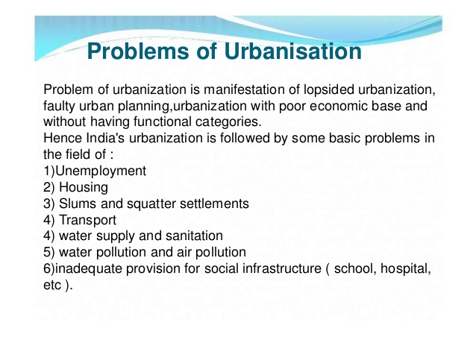
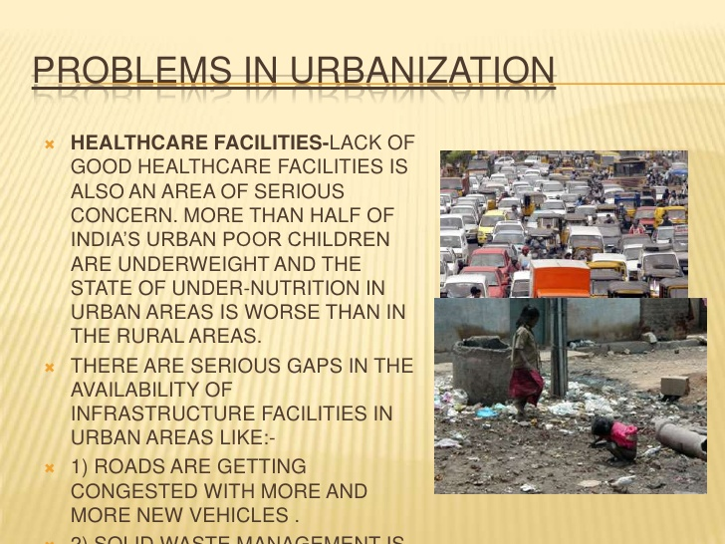
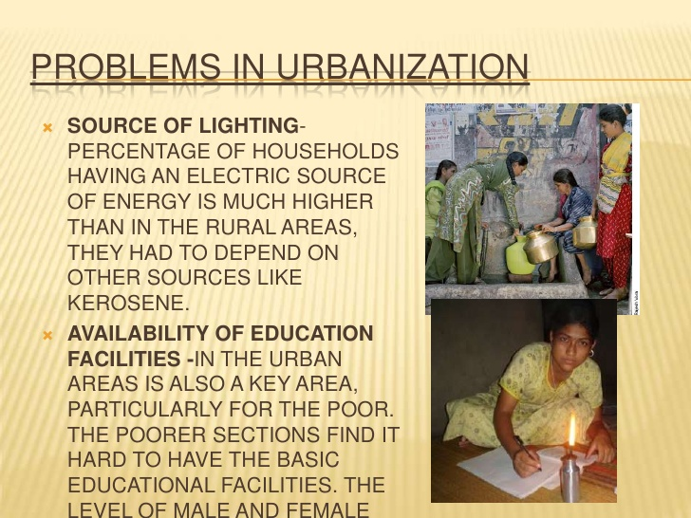
37.degradation of forests criteria
Google it
38.Degradation of forests harmful
Google it
39.Desertization
Google it
40.What is desertification according to UNCCD?
Desertification refers to land degradation in arid, semi-arid and sub-humid areas resulting from various factors, including climatic variations and human activities.
41.What are the causes of land degradation?
Factors that have contributed to land degradation include:
- soil erosion
- loss of soil fertility
- soil structure change
- salinisation
- soil pollution
- desertification
- loss of vegetation cover
- introduced herbivores such as rabbits and goats
- increases of populations of native herbivores such as kangaroos
- overuse of irrigation water.
42.Environmental acts
Look at presentation on environmental legislations
43.What are the main causes of population growth?
- Increase in number of children: In the developing countries increase in number of children helps increase the wealth of a family and provides leisure and old-age security to parents. The family that has more working members can farm more land and become wealthier.
- Decrease in death rate as a result of better sanitation procedures, medical benefits and successful control of diseases and various ailments.
- Early marriage of girls. This increase the child-bearing capacity of women. It is rather opposite to the developed world nowadays.
- Illiteracy among people and lack or non-availability of educational opportunities.
- Lack of birth control
- Religious beliefs
Most of the doctrines in these religions are based on the idea that the deity they worship will prevent or support the birth of a child

- Financial incentives
In certain countries with low population rates, there are financial incentives to produce more children. In the United States, tax deductions were put in place to assist parents with the day-to-day costs of raising a child. In Australia financial incentives given for child birth

- Fertility treatments and IV fertilisation
Modern science has found ways to stimulate the reproductive system in many ways to better ensure a pregnancy.
Drawbacks with this procedure, however, are the chance for increased birth rates in many women
- Morality rate
- Industrial revolution
Which occurred in 19th century Europe and north America, involved several scientific and technological innovations, developments and advancements, have improved the quality of life and have expanded the average life span
- Food production
Since the mid-19th century, many agricultural innovations have enabled farmers to dramatically increase and improve food production.
By 1990, improved medical care and technological advancements facilitating cleaner cities, efficient sewage systems, nutritional knowledge and adequate homes have also lowered death rates.

- Public health
- Cure for serious diseases
Scientific discoveries and technological advancements that help prevent infections, cure illnesses and enable people to survive diseases have significantly promoted population growth.
Vaccines have reduced the rate of infections such as smallpox, influenza, rubella and polio

- Education level
The level of education a woman reaches may have an influence on the number of children she has.
44(a).What is global warming?
- Global warming is changing our world. It is a global threat with real implications for everyone no matter where you live.
- Global warming is caused by a variety of gases and materials in our atmosphere; including huge amounts of carbon dioxide and methane from human activities such as extracting and burning fossil fuels, and clearing forests.
- These gases can trap heat in the atmosphere, causing steadily increasing temperatures.

44(b).What Can We Do About Global Warming?
- We can't realistically stop the rise of CO₂ in the near term, but we can slow it and therefore reduce the consequences that will occur.
- More fuel-efficient cars, less frivolous driving, more use of mass transit, improved insulation to decrease the fuel burned to heat and cool our homes, more efficient appliances,
- saving energy by using efficient devices, use of fluorescent rather than incandescent light bulbs, and careful monitoring of home electricity usage (turn off the lights and TV when not using them) can reduce our energy needs.
- Alternative Fuels: Conversion to alternatives like wind and solar power which don't burn fossil fuels and emit CO₂ into the atmosphere.
- Planting large areas with trees will consume CO₂ as the trees grow, until the forests mature.
- Stopping deforestation in the tropical forests around the world, especially in the Amazon and Indonesian rain forests, will keep that carbon in the forest rather than sending it back into the atmosphere as the trees are burned or decay and are not replaced by more.
- Other techniques have also been proposed such as the chemical removal of CO₂ from smokestacks and burial in deep underground reservoirs.
- Though only certain areas can benefit from this, or disposal in the deep ocean where they will form a semi-stable compound under the cold temperatures and high pressures, though the CO₂ could too easily come bubbling back up.
45.What do you mean by climate change?
Climate change is a change in the statistical distribution of weather patterns when that change lasts for an extended period of time (i.e., decades to millions of years).
Climate change may refer to a change in average weather conditions, or in the time variation of weather around longer-term average conditions (i.e., more or fewer extreme weather events).
46.What are the factors causing climate changes?
Climate change is caused by factors such as biotic processes, variations in solar radiation received by Earth, plate tectonics, and volcanic eruptions.
Certain human activities have also been identified as significant causes of recent climate change, often referred to as global warming

47. What is climate forcing?
Factors that can shape climate are called climate forcings or "forcing mechanisms". These include processes such as variations in solar radiation, variations in the Earth's orbit, variations in the albedo (the proportion of the incident light or radiation that is reflected by a surface, typically that of a planet or moon) or reflectivity of the continents and oceans, mountain-building and continental drift and changes in greenhouse gas concentrations. Forcing mechanisms can be either "internal" or "external". Internal forcing mechanisms are natural processes within the climate system itself (e.g., the thermohaline circulation- the movement of seawater in a pattern of flow dependent on variations in temperature, which give rise to changes in salt content and hence in density.) External forcing mechanisms can be either natural (e.g., changes in solar output) or anthropogenic (e.g., increased emissions of greenhouse gases).
48. What is the effect of climate changes in developing countries?
Developing countries have far fewer resources for adapting to such changes. They may not be able to afford large projects such as sea walls or aqueducts. Peasant farmers may have difficulty adopting new agricultural practices. The resulting social tensions could lead to more political unrest, large-scale migrations, and serious international problems such as terrorism and wars.
49. Effect of climate change in less developed countries?
In contrast, economically less developed societies, like those in parts of Africa, Asia, and South America depend much more directly on climate, and could be hit much harder by sudden or large changes. Places like coastal Bangladesh and low-lying islands, could be flooded by storms or rising sea level.
50. IPCC
- The Intergovernmental Panel on Climate Change (IPCC) is the international body for assessing the science related to climate change. The IPCC was set up in 1988 by the World Meteorological Organization (WMO) and United Nations Environment Programme (UNEP) to provide policymakers with regular assessments of the scientific basis of climate change, its impacts and future risks, and options for adaptation and mitigation. As an intergovernmental body, membership of the IPCC is open to all member countries of the United Nations (UN) and WMO. Currently 195 countries are Members of the IPCC. Governments participate in the review process and the plenary Sessions, where main decisions about the IPCC work programme are taken and reports are accepted, adopted and approved. The IPCC Bureau Members, including the Chair, are also elected during the plenary Sessions. IPCC assessments provide a scientific basis for governments at all levels to develop climate-related policies, and they underlie negotiations at the UN Climate Conference – the United Nations Framework Convention on Climate Change (UNFCCC). The assessments are policy-relevant but not policy-prescriptive: they may present projections of future climate change based on different scenarios and the risks that climate change poses and discuss the implications of response options, but they do not tell policymakers what actions to take.
51. Paris Agreement
- The Paris Agreement is an agreement within the United Nations Framework Convention on Climate Change (UNFCCC) dealing with greenhouse gases emissions mitigation, adaptation and finance starting in the year 2020. The language of the agreement was negotiated by representatives of 195 countries at the 21st Conference of the Parties of the UNFCCC in Paris and adopted by consensus on 12 December 2015. It was opened for signature on 22 April 2016 (Earth Day) in a ceremony in New York City. As of 2 October 2016, 191 UNFCCC members, including India have signed the treaty, 62 of which have ratified it. The agreement will only enter into force provided that 55 countries that produce at least 55% of the world's greenhouse gas emissions ratify, accept, approve or accede to the agreement; although the minimum number of ratifications has been reached, the ratifying states do not produce the requisite percentage of greenhouse gases for the agreement to enter into force.
52. Ozone depletion-ozone hole
- Ozone depletion describes two distinct but related phenomena observed since the late 1970s: a steady decline of about 4% in the total amount of ozone in Earth's stratosphere (the ozone layer), and a much larger springtime decrease in stratospheric ozone around Earth's polar regions. The latter phenomenon is referred to as the ozone hole. In addition to these well-known stratospheric phenomena, there are also springtime polar tropospheric ozone depletion events. The details of polar ozone hole formation differ from that of mid-latitude thinning but the most important process in both is catalytic destruction of ozone by atomic halogens. The main source of these halogen atoms in the stratosphere is photodissociation of manmade halocarbon refrigerants, solvents, propellants, and foam-blowing agents (CFCs, HCFCs,freons, halons).
53. Acid Rain
- Acid rain is a rain or any other form of precipitation that is unusually acidic, meaning that it possesses elevated levels of hydrogen ions (low pH). It can have harmful effects on plants, aquatic animals and infrastructure. "Acid rain" is a popular term referring to the deposition of a mixture from wet (rain, snow, sleet, fog, cloudwater, and dew) and dry (acidifying particles and gases) acidic components. Distilled water, once carbon dioxide is removed, has a neutral pH of 7.
- (There are several slides on acid rain, please go through the ppt once)
54. Burning Plastic
When plastic in municipal solid waste/ household trash burns it results in emission of deadly poisonous chemical commonly called DIOXIN (polychlorinated dibenzo-p-dioxin and polychlorinated dibenzopurans). DIOXIN is a toxic organic chemical that contains chlorine and is produced when chlorine and hydrocarbons are heated at high temperatures. To inhalate DIOXIN or to be exposed to its fumes can result in deadly disease such as lung cancer
55. BPA
BPA leaches from plastics and resins when exposed to hard use or at high temperatures as in microwave ovens and dishwashers or hot milk baby bottles, reusable water bottles, protective linings inside most food/beverage cans. BPA is a endocrine disruptor because it mimics estrogen, a natural hormone.
56. BPA and human health
BPA increases the incidence of heart diseases, diabetes, liver disorders, brain and hormone development problems in fetuses and young children.
BPA promotes breast cancer; brings about early puberty in girls, decreases sperm count in rats.
In 2004 study by the Centre for Disease Control & Prevention (CDCP), USA indicated BPA in urine of 93% of those tested; children are more exposed to BPA – milk bottles, toys, toilet seats, prams, etc all of plastic !!!
57. Difference between cyclone, tornado, and hurricane
A cyclone is an area of closed, circular fluid motion. It has low pressure on the inside and high pressure on the outside. The center of the storm is called the eye and it has the calmest water and lowest pressure.
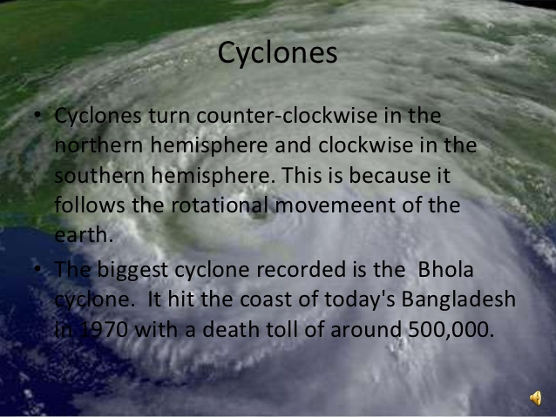
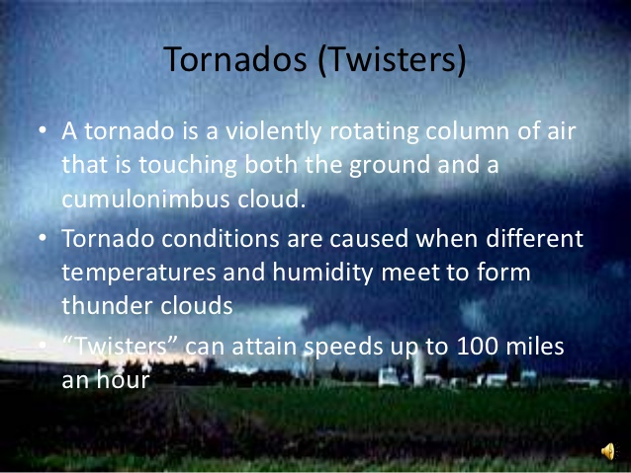
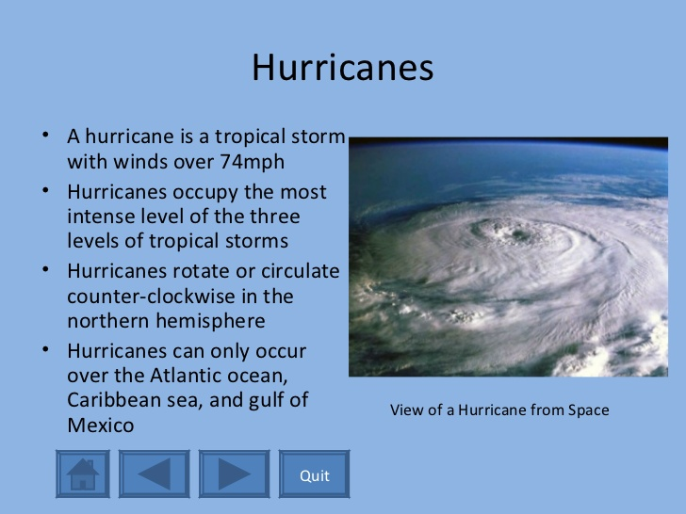

58. What are flash floods. (I couldn’t find the answer so I googled it)
Ans: A flash flood is a rapid flooding of geomorphic low-lying areas: washes, rivers, dry lakes and basins. It may be caused by heavy rain associated with a severe thunderstorm, hurricane, tropical storm, or meltwater from ice or snow flowing over ice sheets or snowfields. Flash floods may occur after the collapse of a natural ice or debris dam, or a human structure such as a man-made dam, as occurred before the Johnstown Flood of 1889. Flash floods are distinguished from regular floods by a timescale of less than six hours.^{[1]} The water that is temporarily available is often used by foliage with rapid germination and short growth cycles, and by specially adapted animal life

59. Earthquakes and Tectonic plates.
Ans: Earthquake (EQ) is the trembling of the earth’s surface. The cause of an earthquake is usually the faults in the rocks – a break along which one rock mass has rubbed on another with great force and friction. The amount of energy involved in this rubbing is converted to vibration of rocks. Elastic energy is stored in rock masses, when the rock mass breaks or slips by another rock mass along an earlier break, the sudden release of stored elastic energy is an earthquake. EQ’s are caused by sudden releases of strain energy accumulated during long intervals due to relative motion of tectonic plates of earth: 6 Major and 6 Minor. EQ’s are of two types: tectonic and volcanic. Tectonic EQ’s are of three types: interplate, intraplate and SCR (Stable Continental Region). EQ of 6.3M has destructive power equal to that of the atomic bomb thrown over Hiroshima.
Tectonic plates are pieces of Earth's crust and uppermost mantle, together referred to as the lithosphere. The plates are around 100 km (62 mi) thick and consist of two principal types of material:
oceanic crust (also called sima from silicon and magnesium) and
continental crust (sial from silicon and aluminium).
60. Top 10 natural disasters
Ans: 1.Cyclone
2.Earthquake
3.Tornado
4.Volcanic Eruption
5.Tsunami
6.Flood
7.Wildfire
8.Drought
9.Avalanche
10.Landslide

61. Vulnerability and disasters
Ans:
The word disaster is derived from Middle French désastre and that from Old Italian disastro, which in turn comes from the Ancient Greek. The root of the word disaster comes from an astrological sense of a calamity blamed on the position of planets.
Disaster is a serious disruption of the functioning of a community or a society involving widespread human, material, economic or environmental loss and impacts, which exceeds the ability of the affected community or society to cope using its own resources.
Natural hazards become disasters when they impact on the vulnerabilities on an area/region and its people. The vulnerability of an area is a complex phenomenon; it is defined as the influence on it by heterogeneity of social, political and economic factors. Natural or man-made hazards impact differently on different areas depending on vulnerability.

62. What are earthquakes (already given).

63. What are avalanches and landslides?
Ans: Avalanche is a sudden and drastic drop of snow. A largescale avalanche can release up to 300,000 cubic yards of snow. They are more commonly released by recreationalists than by natural causes. The biggest avalanche happened in Mt.Huascaran killing 20,000.
Landslide or landslip is a movement in the ground and shallow flow of debris. It is nature’s way of distributing land. They can be triggered by rains, floods ad earthquakes as well as man-made factors like slope grading or mining. They can happen at any place with a steep slope. The biggest landslide in history happened at Mt.St.Helens about 3km of rock moved downhill.

64. What is lightning and how does it come?
Ans: Lightning is a bright flash of static electricity produced by a thunderstorm. Part of a cloud becomes negatively charged and part of a cloud becomes positively charged, Lightning acts to balance by creating positive or negative flows of current. Most lightning is “sheet lightning”. Other more dangerous type is called “cloud-to-ground lightning.” The electrons are attracted to positive charges of other clouds or the ground.
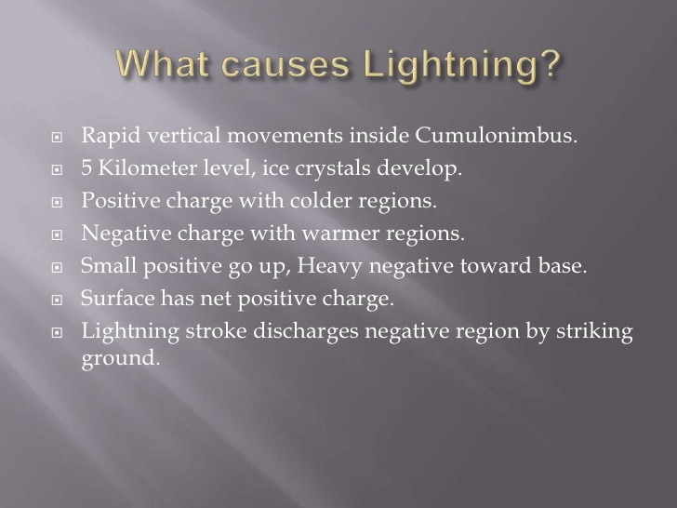

65. What are natural pollutants?
Ans: Natural pollutants are the result of natural phenomena
1.Forest fires started by lightning
2.Dispersal of pollen, soil erosion and volcanic eruptions
3.Discharge of volatile organic compounds (VOCs) from leaves and trees
4.Decomposition or purification of organic matter
4.Natural radioactivity

66. What is eutrophication?
An increase in chemical nutrients, typically compounds containing nitrogen or phosphorus, in an ecosystem. It can result in an increase in the ecosystem's primary productivity (excessive plant growth and decay), and further effects including lack of oxygen and severe reductions in water quality, fish, and other animal populations.

67. What is acidification?
The oceans are normally a natural carbon sink, absorbing carbon dioxide from the atmosphere.
Because the levels of atmospheric carbon dioxide are increasing, the oceans are becoming more acidic. Biological organisms made of calcium carbonate becoming vulnerable to dissolution, affecting corals and the ability of shellfish to form shells. Rising ocean temperatures and ocean acidification means that the capacity of the ocean carbon sink will gradually get weaker.
68. Thermal pollution
Release of heat into the atmosphere and water bodies is called thermal pollution.
Heavy and small industries use water for cooling purposes. This water gets heated and then released into water bodies, thereby increasing the temperature. Natural causes of thermal pollution are the forest fires and the volcanic eruptions. If the temperature in oceans is raised by 1 degree, the environment becomes lethal to sensitive organisms.

